**Cle-Elum, Summer  
CR – residuals are not normal and variances are unequal, log transform doesn’t help, leptokurtic distribution**

numDF F-value p-value

(Intercept) 1 729.2024 <.0001  
N 1 152.7756 <.0001  
P 1 22.1681 <.0001  
Si 1 6.3382 0.0170  
N:P 1 10.6442 0.0026  
N:Si 1 0.0488 0.8266  
P:Si 1 50.0622 <.0001  
N:P:Si 1 22.4956 <.0001

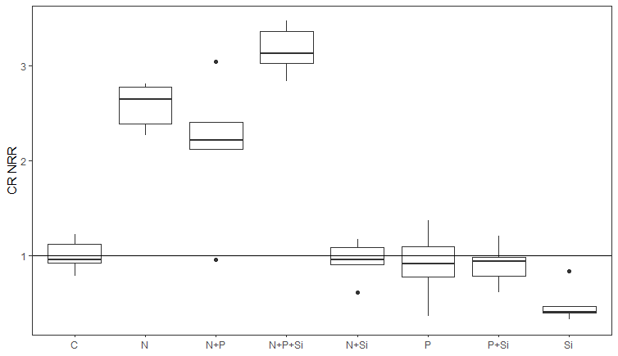

INTERPRETATION: N limitation (N, N+P, N+P+Si are all high), Si no effect or inhibition (N+Si, P+Si are circum 1, Si is lower than 1)

**GPP – residuals are not normal and variances are unequal, remove Z2 outlier?**

Denom. DF: 32   
 numDF F-value p-value  
(Intercept) 1 113.66310 <.0001  
N 1 5.40374 0.0266  
P 1 0.39096 0.5362  
Si 1 1.65738 0.2072  
N:P 1 1.59638 0.2155  
N:Si 1 0.84306 0.3654  
P:Si 1 1.50194 0.2293  
N:P:Si 1 0.20261 0.6557

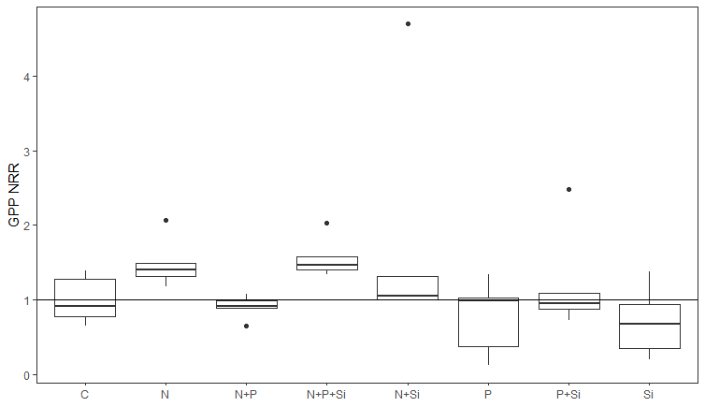

N limitation based on N, N+P+Si,N+Si treatments? P inhibition based on P and N+P treatments?